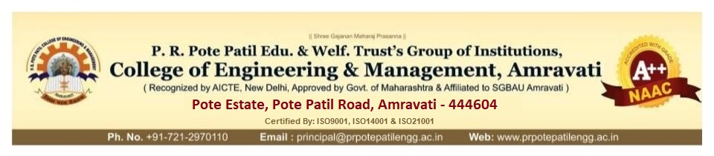

Date:

**Sub: Smart India Hackathon 2023 – Nomination**

I am pleased to nominate the below team from our college to participate in Smart India

Hackathon 2023. AICTE Application No./ UGC Registration No for our college is ___________________.

**Team :** Bug Smashers

|  |  |  |  |  |
| --- | --- | --- | --- | --- |
|  | **Name** | **Gender (M/F)** | **Email id** | **Mobile no.** |
| Team Leader | Rushikesh Prakash Shirke | M | [p.rushikeshshirke@gmail.com](mailto:p.rushikeshshirke@gmail.com) | 8788986861 |
| Team Member | Shreyas Sanjaykumar Patil | M | [shreyas.patil237@gmail.com](mailto:shreyas.patil237@gmail.com) | 9960130060 |
| Team Member | Shivraj Arvind Kadam | M | [shivrajkadam200@gmail.com](mailto:shivrajkadam200@gmail.com) | 7721031161 |
| Team Member | Sanika Dipak Kale | F | [sanikakale8010@gmail.com](mailto:sanikakale8010@gmail.com) | 8010082744 |
| Team Member | Arpita Vilasrao Dolas | F | [arpitadolas@gmail.com](mailto:arpitadolas@gmail.com) | 9322379434 |
| Team Member | Apeksha Rajkumar Gadpayle | F | [apekshagadpayle@gmail.com](mailto:apekshagadpayle@gmail.com) | 9370283944 |

Sincerely,

Dr. Mohammad. Zuhair

Principal